|  |
| --- |
| Voortex Protocol whitepaper  First AI-Layer 2 on Solana |
| $VOORX |

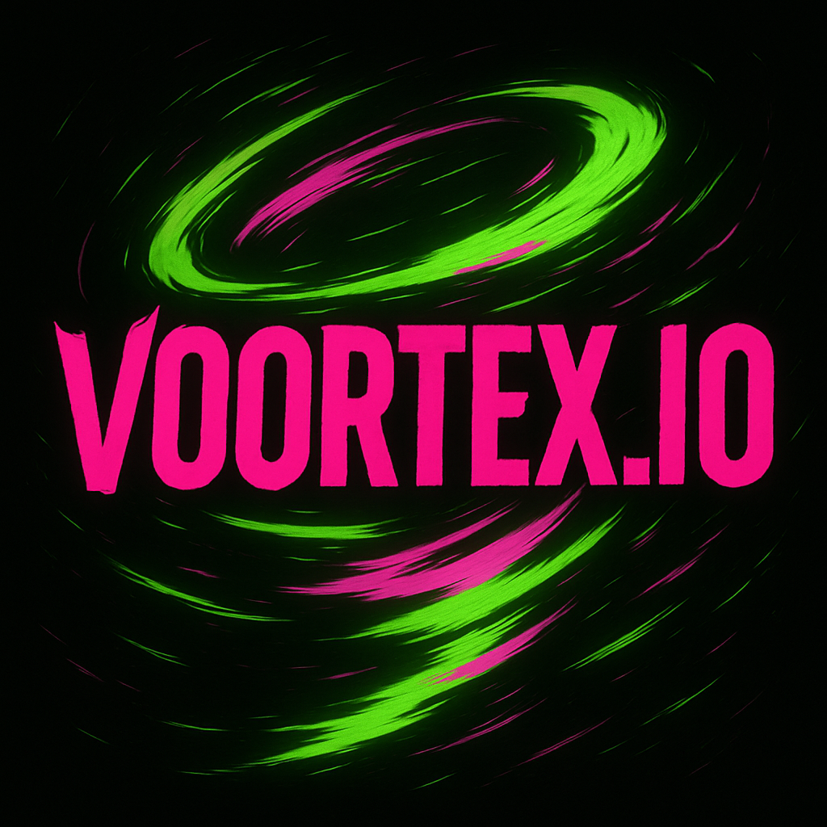

**Voortex Protocol — The AI-Native Layer 2 for Solana**

### Whitepaper v1.0 — May 2025

**🔹 Executive Summary**

Voortex Protocol is the first AI-native modular Layer 2 built to supercharge the Solana ecosystem. By combining high-throughput rollups, decentralized inference, and gas-efficient modular execution, Voortex empowers a new generation of decentralized applications: intelligent, scalable, and lightning-fast.

Built on top of Solana’s performance layer, Voortex introduces AI-as-a-primitive: enabling smart contracts to query, compute, and verify AI outputs on-chain, without compromising speed or security.

**🔭 Vision & Mission**

**Vision**:  
To become the leading execution layer for AI-integrated Web3 applications, where intelligence meets decentralization.

**Mission**:

* Bring real-time AI into Layer 2 smart contracts
* Democratize access to decentralized inference
* Optimize Solana's scalability through AI-enhanced rollups
* Power the next wave of Web3 dApps: gaming, agents, finance, identity, prediction

**🔥 Why Voortex Protocol (vs Ethereum/Solana bottlenecks)**

**Ethereum** is modular, secure, but too slow and expensive for AI or real-time UX.  
**Solana** is fast, but still monolithic and not built for on-chain inference.

**Key Bottlenecks Today**:

* No native AI primitive
* Inference is off-chain & centralized
* Smart contracts can’t verify AI outputs
* Gas models are incompatible with compute-heavy tasks
* Rollups on Solana are early and lack modularity

**Voortex fixes this with:**

* AI-optimized modular rollups
* Inference layer with staking
* Modular gas layers
* Zero-knowledge integrity (coming)
* Full Solana composability

**⚙️ Protocol Architecture**

Voortex is built as a modular Layer 2 stack over Solana with three execution zones:

1. **AI Execution Layer**
   * Decentralized inference network
   * Models can be staked, queried, and monetized
2. **Rollup Layer**
   * Bundles compute-intensive transactions
   * Posts proofs & summaries to Solana L1
3. **Settlement Layer (Solana)**
   * Ensures finality, consensus, and cross-ecosystem interoperability

Each layer is separated for scalability and upgradeability.

**🧬 Layer 2 Design**

Voortex supports a **hybrid modular design** with:

* **Optimistic rollups** for throughput
* **Validium-style zk-proofs** for integrity (phase 2)
* Modular **gas model** based on computation units
* Modular **runtime environments** for AI use cases

This enables real-time dApps that use AI without waiting for expensive on-chain validation.

**🤖 AI-Native Capabilities**

Voortex introduces **AI-as-a-primitive**:

* Query any on-chain or verified AI model from your smart contract
* Incentivized staking for inference nodes
* Reputation system for model accuracy
* Slashable incorrect inference (future)

Developers can use **Voortex SDK** to integrate models like:

* LLMs (GPT-4, Claude, Mistral)
* Vision & biometric AI
* Predictive ML for DeFi
* Autonomous agents & oracles

**💡 Use Cases**

* **AI Agents** on-chain (wallets, bots, agents)
* **Prediction markets** with on-chain AI scoring
* **Biometric/Voice ID** for authentication
* **Gaming** with AI NPCs
* **DeFi** with real-time market prediction
* **Identity protocols** with AI-backed KYC (opt-in)

**💰 Tokenomics**

**Token**: $VOORX  
**Total Supply**: 1,000,000,000 tokens

| **Allocation** | **%** | **Notes** |
| --- | --- | --- |
| Ecosystem Growth | 30% | Grants, devs, liquidity |
| Team & Advisors | 20% | Teams, Advisors, organic. |
| Strategic Partnerships | 15% | Infra, cloud, DePIN integrations |
| Presale Rounds | 15% | claimable at the official CEX/DEX launch |
| Liquidity & Market Making | 10% | CEX, DEX bootstrapping |
| DAO Treasury | 5% | Governance & bounties |
| Airdrops & Campaigns | 5% | Early users, social quests |

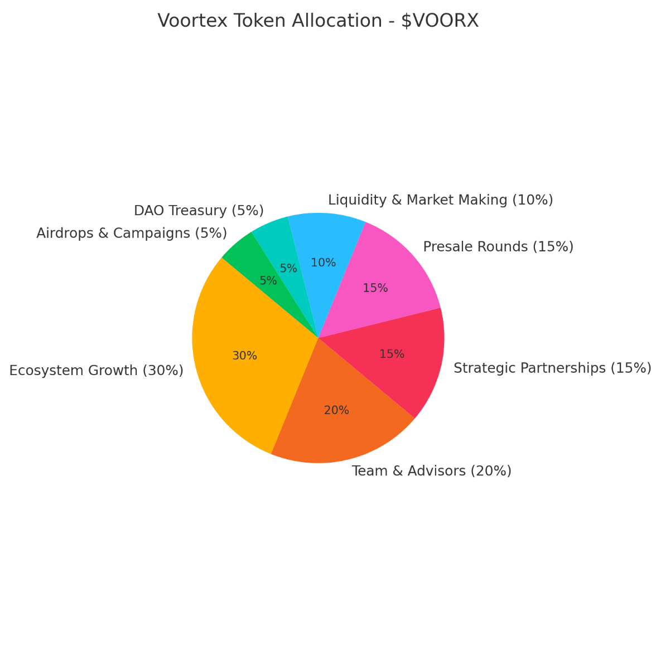

**🗺️ Roadmap**

| **Quarter** | **Milestone** |
| --- | --- |
| Q2 2025 | Website, whitelist, token creation, pre-sale. |
| Q3 2025 | AI Node testnet, dev SDK, first rollup beta |
| Q4 2025 | Staking live, first dApps launched, audits begin |
| Q1 2026 | DAO creation, mainnet v1, listings (CEX & DEX) |
| Q2 2026 | zk-integrity module, cross-chain AI bridges |

**🗳️ Governance & DAO**

Voortex will launch a DAO governed by $VOORX holders with powers to:

* Propose protocol upgrades
* Fund new AI models & dApps
* Manage treasury and staking incentives
* Vote on integrations and partners

DAO treasury will be multi-sig governed, transitioning to on-chain DAO Q1 2026.

**🧠 Voortex Protocol – Core Team**

**👤 "MetaFlux" – *Founder & Project Lead***

With a background in strategic leadership and innovation management, MetaFlux previously worked in digital transformation and high-growth ventures. As the non-technical founder of Voortex, he leads the project's vision, coordinates multidisciplinary teams, manages strategic partnerships, fundraising, and ensures execution stays aligned with long-term goals.

*“Voortex is where speed, intelligence, and decentralization converge. My role is to turn bold ideas into a real, thriving protocol.”*

**⚙️ "TensorZero" – *Chief AI Architect***

An ML engineer with experience in decentralized AI infrastructure and open-source contributions (HuggingFace, Stability.ai). Leads the design of the inference layer, staking mechanisms for AI models, and verifiability systems.

*“AI should be accessible, verifiable, and native to Web3.”*

**💻 "SolCoder" – *Lead Protocol Engineer***

A Rust/Solana expert with deep experience in DeFi and Layer 2 development. Responsible for Voortex’s modular rollups, developer SDK, and real-time AI runtime environments.

*“We’re not just scaling Solana. We’re redefining what smart contracts can do.”*

**🔒 "ZKronos" – *ZK & Security Architect***

Specialist in zero-knowledge proofs, cryptographic systems, and Web3 security. Oversees protocol audits, zk-integrity modules, and zkML development for inference trustworthiness.

*“No AI should be blindly trusted—proofs must scale with intelligence.”*

**🌐 "Vox" – *Community & DAO Governance Lead***

With a background in Web3 culture and DAO design (former contributor to MonkeyDAO and Jito), Vox manages Voortex’s community growth, XP system, DAO governance mechanisms, and social quests.

*“Narratives attract attention. Communities build value.”*

**📡 "0xNova" – *Partnerships & DePIN Strategist***

Focuses on aligning Voortex with DePIN infrastructure, decentralized storage networks, oracle providers, and AI/ML ecosystem partners for interoperability and growth.

*“The future of AI is not just smart—it’s decentralized.”*

**🔐 Security & Audits**

* **Smart contract audits** via Halborn & OtterSec (TBA)
* zk modules audited before activation
* Bounty program with Immunefi
* Inference node verifiability roadmap (zkML)

**🌐 Community & Social Layer**

Voortex will build a strong memetic + technical identity:

* Twitter/X: [@VoortexProtocol](https://x.com/VoortexProtocol)
* Telegram: [t.me/VoortexProtocol](https://t.me/VoortexProtocol)
* GitHub: [github.com/VoortexProtocol](https://github.com/VoortexProtocol)

Community will earn XP via quests, contributions, testnet activity, and governance.

**⚖️ Legal Disclaimer**

$VOORX is a utility token and not a security.  
Participation in the Voortex Protocol is voluntary and at the user’s own risk.  
This document does not constitute financial advice or investment solicitation.